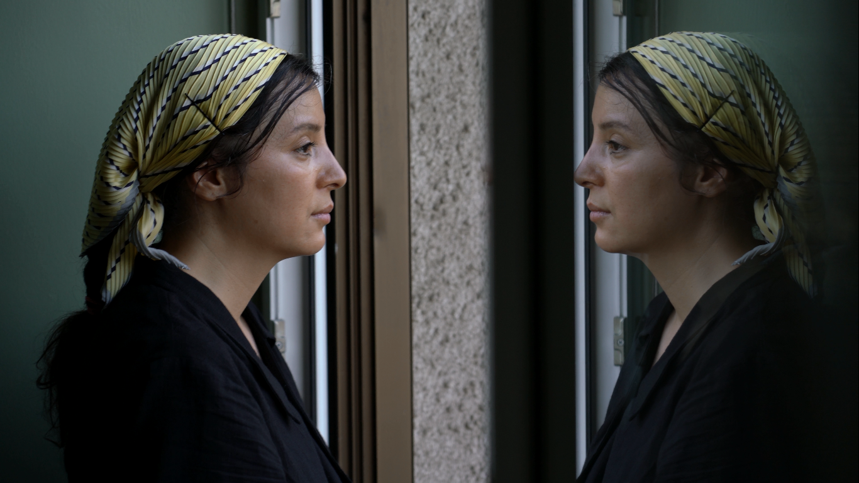

**Stateless as wind**

**Autobiographical Documentary by Samereh Rezaei 2015_2025**

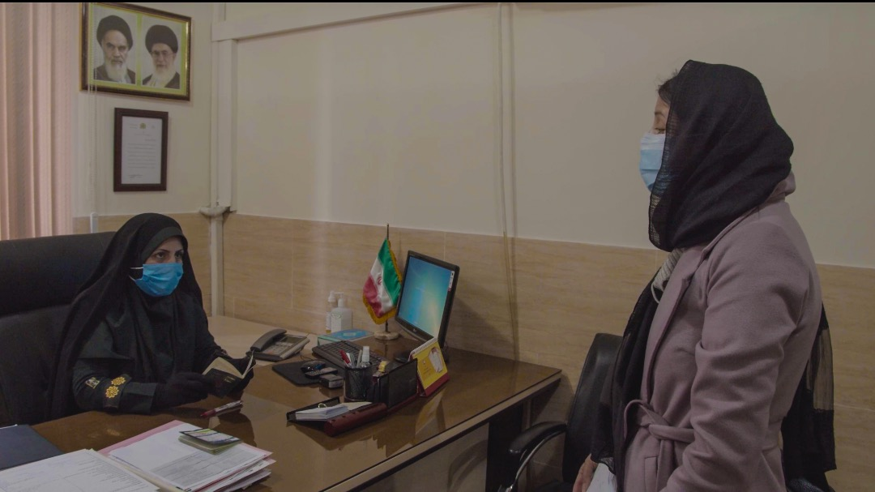

Iran, Tehran, trying to stay in my hometown, last-ditch pleas to convince the Islamic Republic of Iran Police

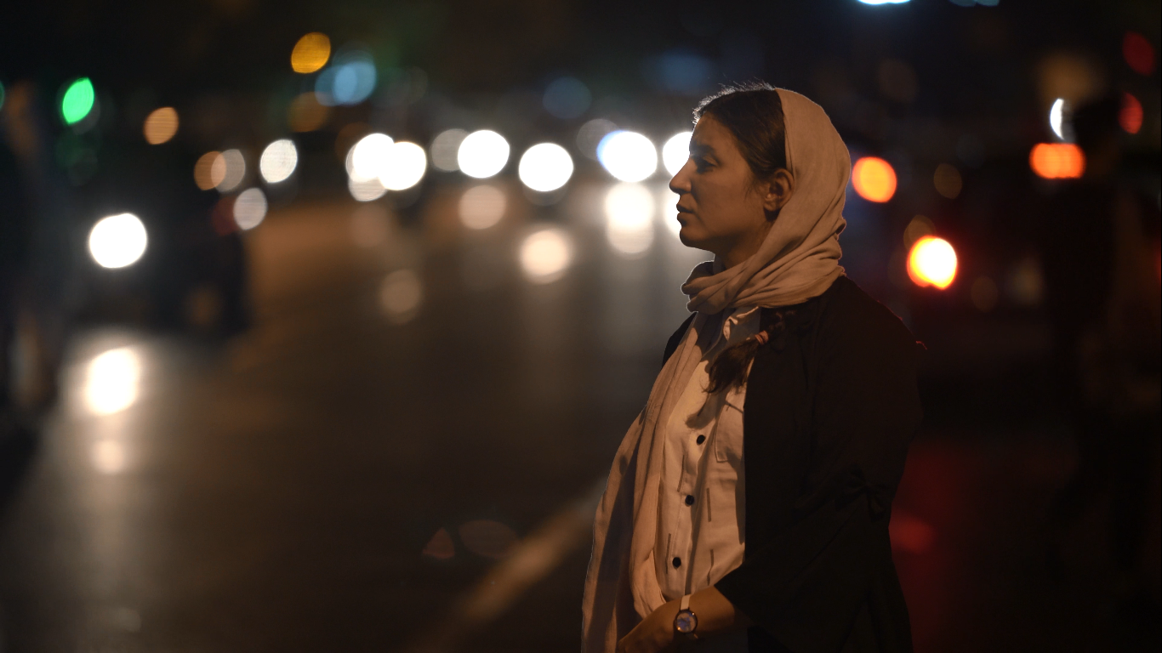

**A poetic journey through exile, womanhood, and the wind of belonging.**

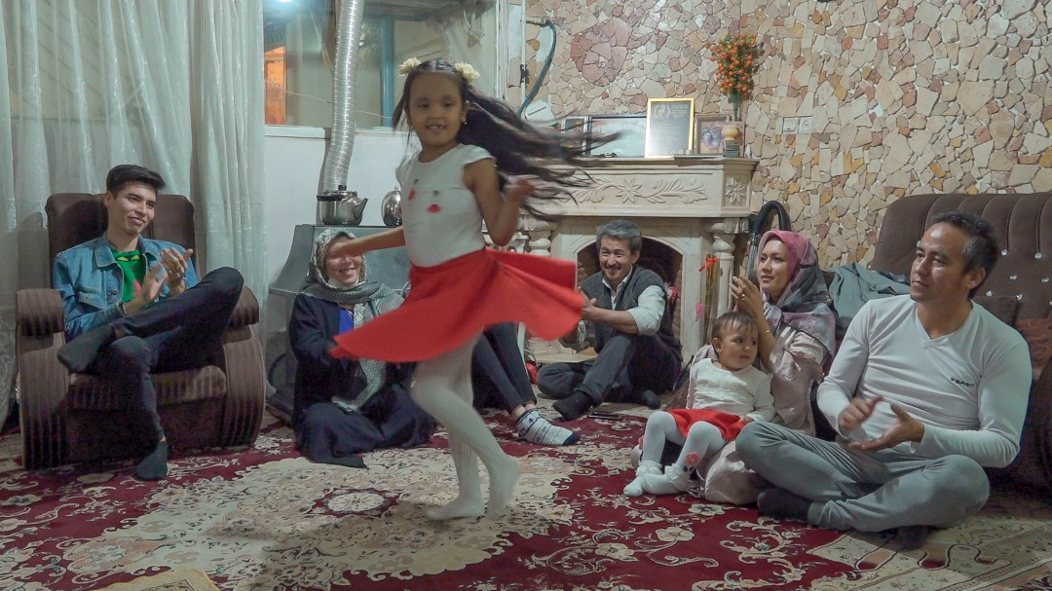

“Yasna and Delsa” — my brother’s little girls, a third generation still foreign to the land they call home.

Unaware of what awaits them, they dance — free, bright, and untouched by destiny.

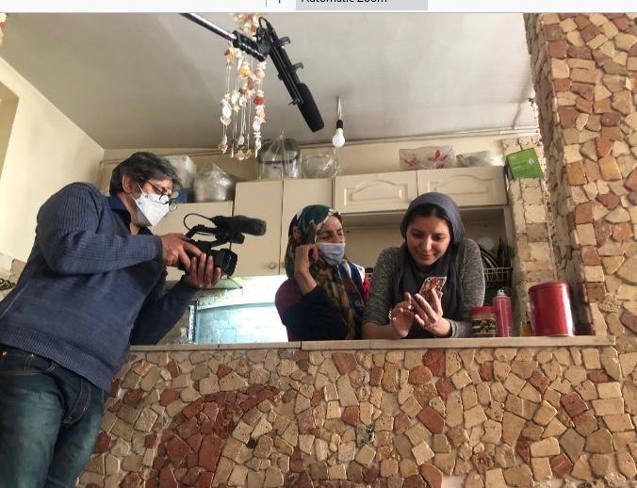

My mother — a woman who was separated from her home during the Soviet war forty years ago.

After years of struggle, she now tries to preserve what is left of it… but what truly remains of home?

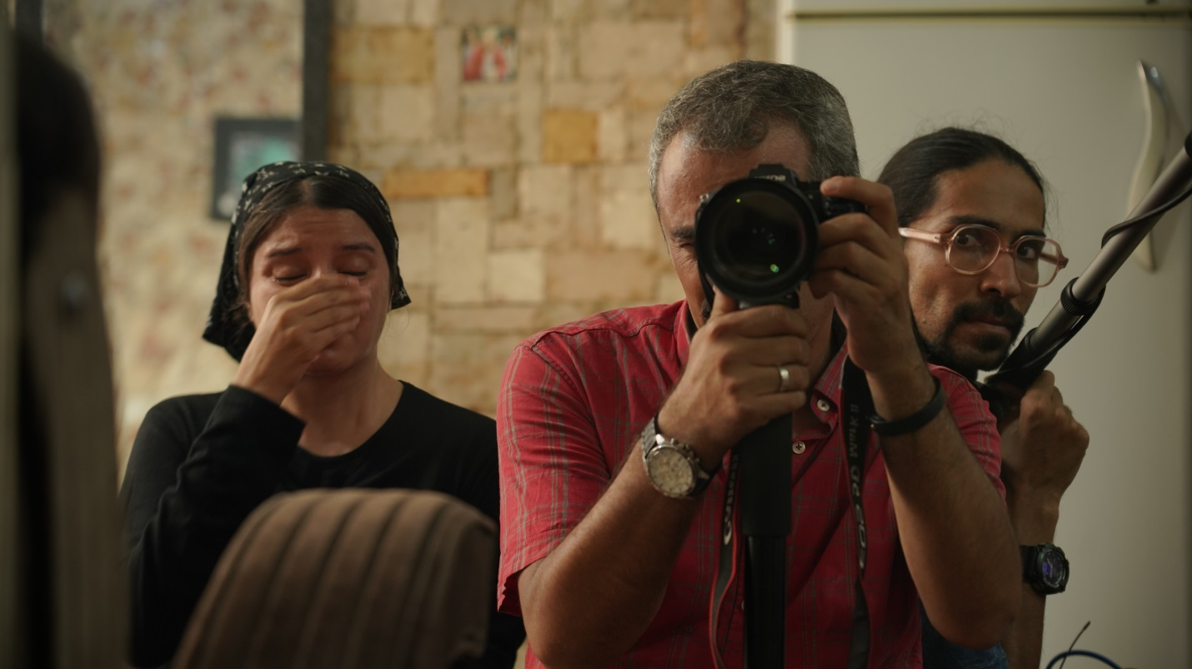

Afghanistan — the only corner of the world that was truly ours. Now I stand helpless, watching it crumble, moment by moment…

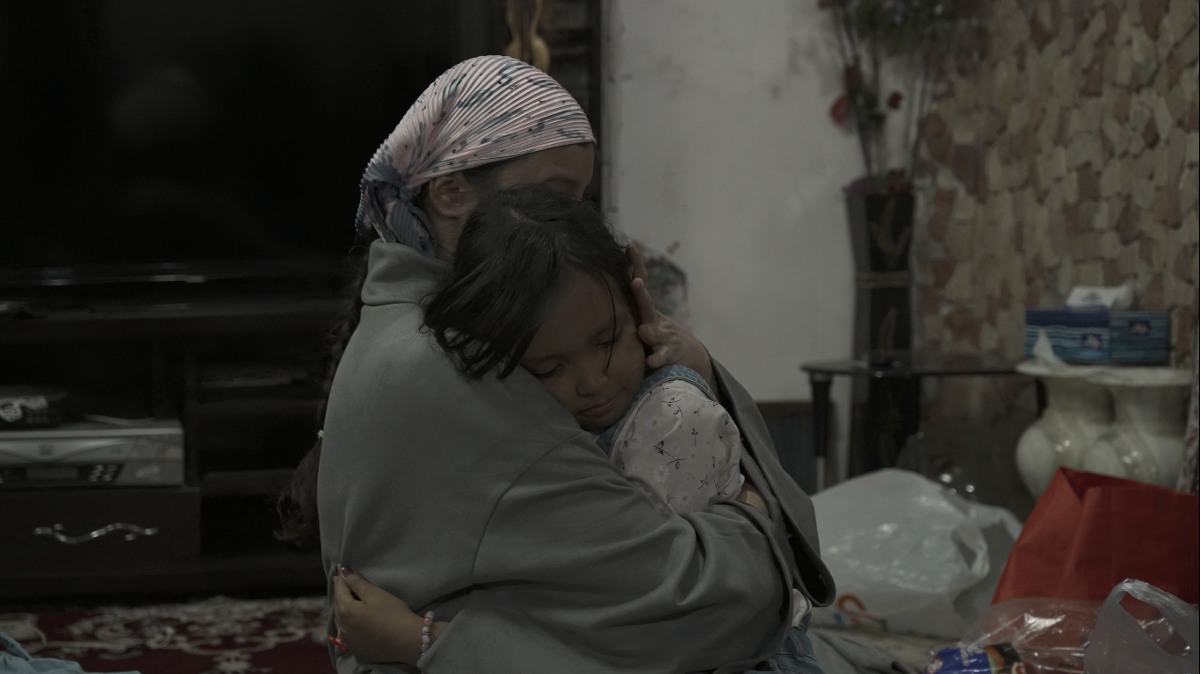

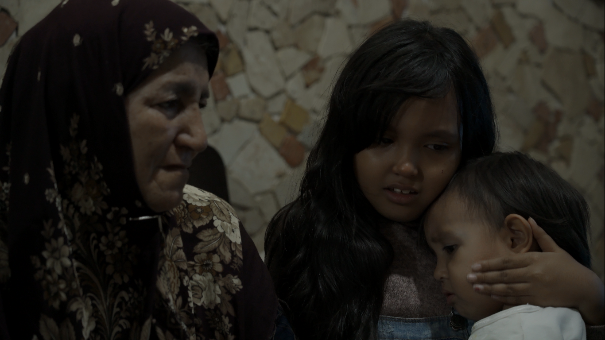

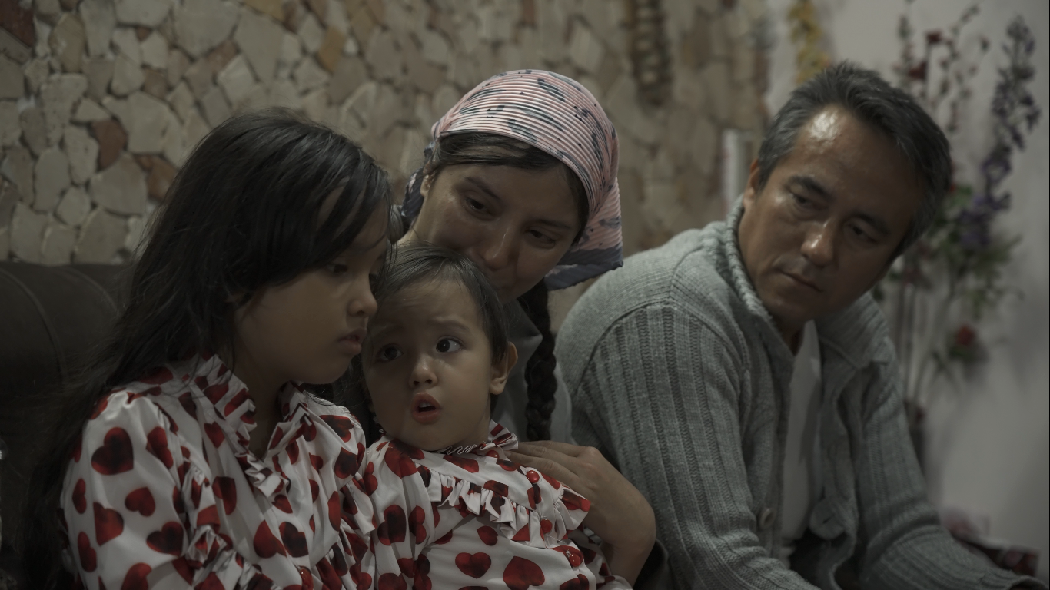

The children who become victims of exile — they grow up amid the silence of broken goodbyes, learning too soon what it means for a family to fall apart.

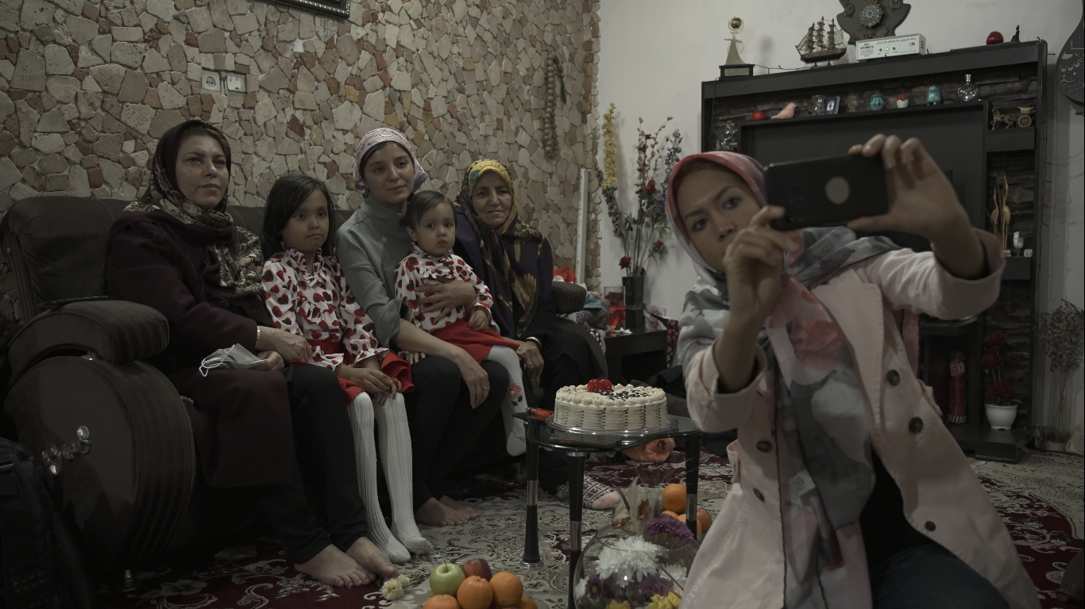

Women from different generations, gathered in a single frame — each a victim of exile. Mother, who came to Iran forty years ago. Pari, who grew up on its soil. Samereh, the second generation, born here. Yesna and Delsa, the third — children who have never known another land.

And yet, they all carry the same mark of identity: foreign nationals.

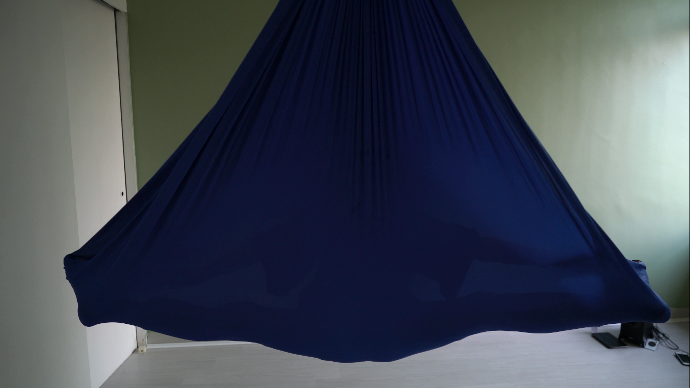

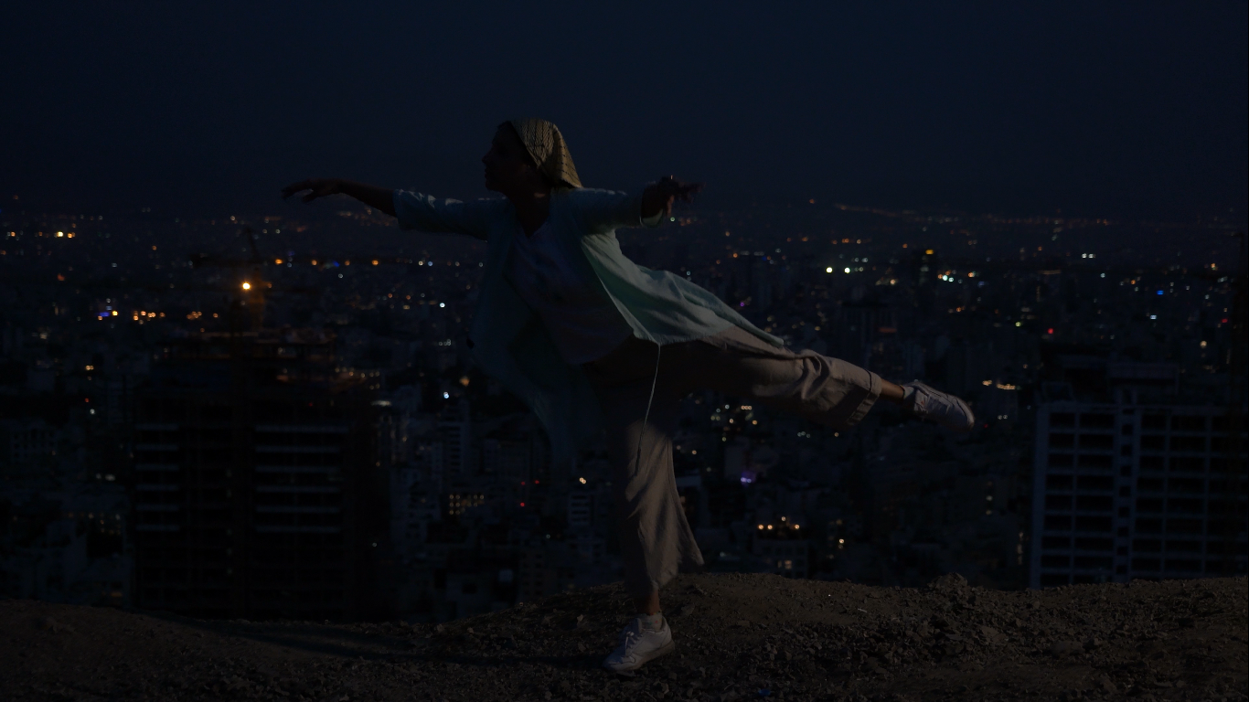

Lost and disoriented, I dance. I take refuge in the inner world, searching for myself.

